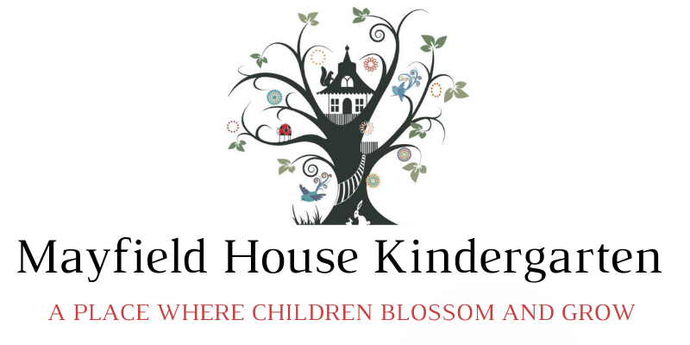

Hello All,

An attempt to explain Nursery Funding:

To claim Funding for under 3’s, and 30 hour funding for 3-5 year olds, you will need to get an eligibility code from . [www.childcarechoices.gov.uk](http://www.childcarechoices.gov.uk)

This needs to be done the term before your child becomes eligible, or you will lose a terms funding.

You can also join the tax-free childcare scheme, which will save you an extra 20% on fees to register apply on

www.childcarechoices.gov.uk

* Gov Nursery education is **not** completely free- except in certain circumstances.

(We offer 1 free/ funded only, place for children allocated 2 year old funding based on need and on a first come basis)

* Funding hours are based on school terms: **38 weeks per year only**

We stretch funding across the year therefore 15 hour funding becomes 10.96 hrs funding and 30 hrs funding becomes 21.92 hrs funding.

* Funding is not intended to cover the costs of meals, nappies, consumables etc. and trips. We make a supplementary charge for these
* Funding is claimed termly – changes to claim cannot be made mid-term- I need to know your needs before the end of the previous term
* The Gov hourly rate does not currently go anywhere near to how much it costs for us to provide our services, and consequently we need to charge our supplement for consumables/ food etc.
* The Government hourly rate also reduces as children get older, but we average out the rate across all ages therefore keep the fees the same price for everyone.
* Our costs may be higher than school nurseries, and some other settings. This is due to our high staff child ratios which we believe is necessary to fulfil our commitment to high quality nurture, care and education.,

Our staff /child ratios are:

0-2 1:4

2-3 1:4 (regulation standard 1:5)

3-5 1:6 (regulation standard 1:8. School settings 1:15)

* Our other costs are probably higher due to high quality environment, equipment and highest quality food - we will not lower our standards.
* **Ultimately though, the government funding is a bonus.**
* **Plus, you can still save an extra 20% on your fees using your gov. tax free childcare account**
* I have attached a spreadsheet of hours / fees, this is based on current hourly rate and our current fees.

I realise this is all very confusing, do call if you need me to try and explain further